# Objectives

* Explain git ignore
* Explain how to ignore unwanted files using git ignore In this hands-on lab, you will learn how to:
* Implement git ignore command to ignore unwanted files and folders

# Prerequisites

The following are the pre-requisites to complete this hands-on lab:

* Setting up Git environment
* Integrate notepad++ as a default editor
* A Git repository in the local system and a remote repository in GitLab Estimated time to complete this lab: **20 minutes.**

Create a **“.log”** file and a **log folder** in the working directory of Git. Update the **.gitignore** file in such a way that on committing, these files (.log extensions and log folders) are ignored.

Verify if the git status reflects the same about working directory, local repository and git repository.

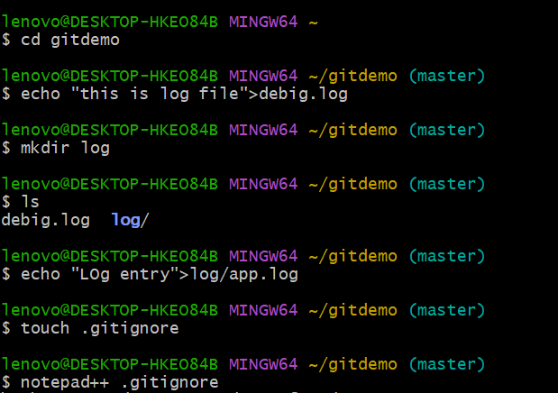

In the Notepad++ type this: # Ignore all .log files

*.log

# Ignore the log folder and its contents log/

